# Data analysis & data acquisition

The initial step to achieve gesture recognition via the accelerometer of the smartphone is to collect data. For this purpose, the Android App ``Accelerometer Analyzer’’, which is accessible through the Google Play Store, is used to record acceleration sensor data while performing different gestures.

The following diagram shows the acceleration distribution across the smartphone acceleration axes.

Figure 1 - Acceleration of smartphone axes

Conducting several measurements, it becomes clear that the acceleration distribution depends on the orientation of the smartphone. A formula is required to calculate the smartphone’s acceleration in the direction of x and z independent its rotation (see chapter 1.3). The values that are measures if these formulas are applied are depicted in figure \ref{fig:finalExcel]}.

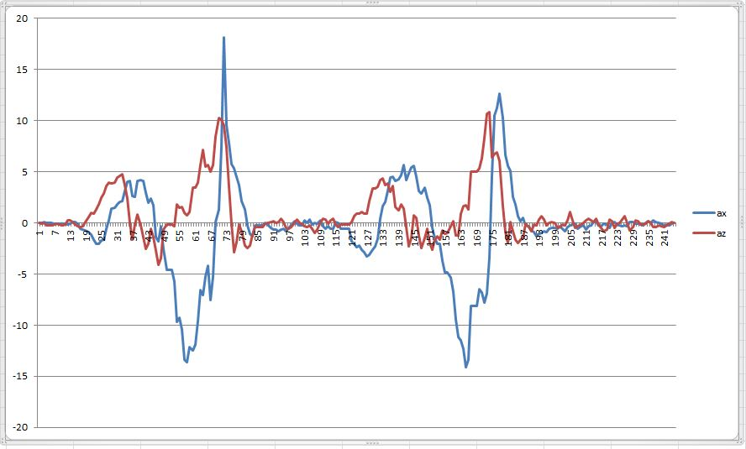

Figure 2 - calculated x and z acceleration of two circles

With this data it was possible to define milestone points to identify a gesture as a circle.

## Acceleration milestones

The tables \ref{tab:milestonesCcw} and \ref{tab:milestonesCw} show the defined acceleration values which have to be reached to recognize a gesture as a circle in the clockwise/counterclowckwise direction.

In each state the calculated acceleration values in the direction of x or z respectively have to reach the predefined values within a specified time slot (0,3s) to get to the next state. Besides that, each state defines a reset value which resets the current circle recognition. This is necessary to prevent false positives (e.g. while shaking the smartphone fast).

Clockwise:

|  |  |  |  |
| --- | --- | --- | --- |
| state | Ax | az | reset condition |
| 1 | < -3 | > 3 | - |
| 2 | > 5 | > 3 | az < -5 |
| 3 | > 5 | < -3 | ax < -5 |
| 4 | < -5 | < -3 | az > 10 |
| 5 | < -5 | > 5 | ax > 5 |

Counterclockwise

|  |  |  |  |
| --- | --- | --- | --- |
| state | Ax | az | reset condition |
| 1 | < 3 | > 3 | - |
| 2 | < -5 | > 3 | az < -5 |
| 3 | > 5 | < -3 | ax > 5 |
| 4 | > 5 | < -3 | az > 10 |
| 5 | > 5 | > 5 | ax > -5 |